**Project synopsis on**

**OBSTACLE DETECTING ROBOT**

Under taken by:

Name 1: Ayushi Anusmita Roll no: BSIT/16/007

Name 1: Varun Tiwari Roll no: BSIT/16/021

**ABSTRACT:**

A Collision Avoidance System reduces the severity of an accident. Also known pre-crash system, forward collision warning system or collision mitigating system, it uses [radar](https://en.wikipedia.org/wiki/Radar) and sometimes [laser](https://en.wikipedia.org/wiki/Lidar) and camera (both sensor types are ineffective during bad weather) to detect an imminent crash. Once the detection is done, these systems either provide a warning to the driver when there is an imminent collision or take action autonomously without any driver input (by braking or steering or both).

In [robotics](https://en.wikipedia.org/wiki/Robotics), obstacle avoidance is the task of satisfying some control objective subject to non-intersection or non-collision position constraints. In [unmanned air vehicles](https://en.wikipedia.org/wiki/Unmanned_air_vehicle), it is a hot topic. What is critical about [obstacle](https://en.wikipedia.org/wiki/Obstacle) avoidance concept in this area is the growing need of usage of unmanned aerial vehicles in urban areas for especially military applications where it can be very useful in city wars. Normally obstacle avoidance is considered to be distinct from [path planning](https://en.wikipedia.org/wiki/Motion_planning) in that one is usually implemented as a reactive control law while the other involves the [pre-computation](https://en.wikipedia.org/wiki/Pre-computation) of an obstacle-free path which a controller will then guide a robot along.

**WORKING PRINCIPLE:**

As the robot moves on the desired path, the ultrasonic sensor transmits the ultrasonic waves continuously from its sensor head. Whenever it approaches an obstacle, the ultrasonic waves are reflected back from the obstacle and that information is passed to the microcontroller. The microcontroller controls the motors (left, right, back, front) based on ultrasonic signals. In order to control the speed of each motor Pulse Width Modulation is used (PWM).

**BLOCK DIAGRAM:**

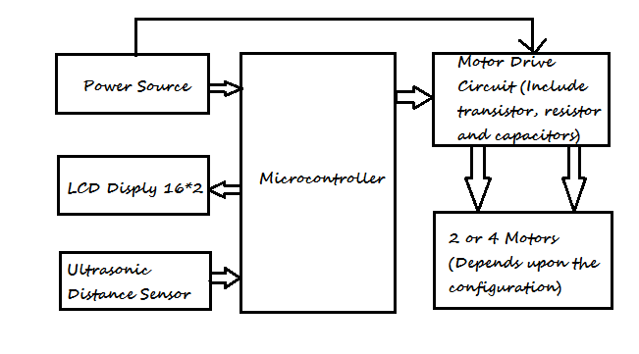

Connections:

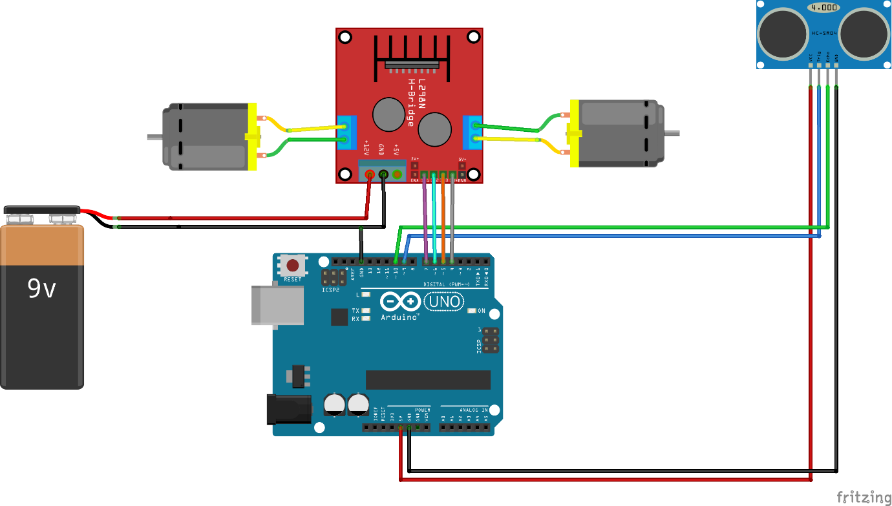

**COMPONENTS REQUIRED**

**🡪 HARDWARE**

1. Breadboard
2. General purpose Board
3. Single Strand Wires (Black, Red, Blue)
4. DC Power Supply (Using 9V Battery)
5. DC 150 RPM Motors
6. Arduino UNO/AVR
7. Ultrasonic Distance Sensor HC-SR04
8. Chassis
9. Jumpers

**🡪 SOFTWARE**

1. Arduino Software/ VMlabs

**APPLICATIONS:**

* The Obstacle Detection is used in Smart Stick for Visually Impaired Persons
* It is also used in Google Driverless Car for the detection in Obstacles.
* The system works on the principal of SONAR and RADAR and thus has infinite scope in aviation and navy.
* The system is also used in Parking Sensors Of the modern cars

**REFERENCES:**

https://www.elprocus.com/obstacle-avoidance-robotic-vehicle/

<http://www.slideshare.net/snesajid/obstacle-detector-robot>

<http://www.instructables.com/id/How-To-Make-an-Obstacle-Avoiding-Arduino-Robot/>